**beaufort seal**

Town of Beaufort NC

701 Front St. • P.O. Box 390 • Beaufort, N.C. 28516

252-728-2141 • 252-728-3982 fax

[www.beaufortnc.org](http://www.beaufortnc.org)

**For Immediate Release**

**Oct. 11, 2019**

**Town of Beaufort to bring Awareness to Pedestrian and Bicycle Safety**

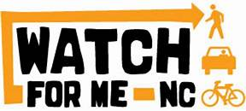

**BEAUFORT -** On Tuesday, Oct. 15, the Town of Beaufort, a Watch for Me NC partner, will host a safety awareness program at the crosswalk at the intersection of Turner and Front Streets. The Beaufort Police Department will be conducting education awareness and enforcement actions while members of the Beaufort Fire Department and Beaufort Parks & Recreation distribute information about bicycle and pedestrian safety. The event will take place between 11 a.m. and 1 p.m.

We all share the responsibility to make sure North Carolina roads are safe for everyone, including pedestrians and bicyclists. Safe places to walk and bike are important for supporting active, vibrant communities. The “Watch for Me NC” program aims to reduce pedestrian and bicycle injuries and deaths through a comprehensive, targeted approach of public education, community engagement, and high visibility law enforcement.

“This educational awareness campaign is just as much for our pedestrian traffic as it is for our vehicular traffic,” said Beaufort Police Chief Paul Burdette.

The Town of Beaufort was named a Watch for Me NC community for 2019. Watch For Me NC is a critical component of community safety planning. The short-term goal is to raise awareness for bicycle and pedestrian safety issues within communities and the agencies serving the public in the realm of transportation safety. The long-term goal is to build a culture of safety around bicycling and walking in the state of North Carolina.

October 15 is also White Cane Awareness Day. Beaufort Resident and Beaufort Parks & Recreation Advisory Board Member Peter Crumley will join the Town in their efforts to increase awareness. Crumley, as a blind person who walks with a white cane and a leader dog, will lead the educational awareness about crosswalk awareness and the importance of white canes for the blind, sharing his first hand knowledge.

“The blind must rely on special learned orientation and mobility skills to remain independently mobile, along with an uncertain level of faith that the driving public will completely yield the right of way when a blind walker is making a street crossing at a designated crosswalk as traffic is required to remained stop in both directions until the blind walker has successfully completed crossing the street,” Crumley said.

White Cane Awareness Day is celebrated nationwide by the National Federation of the Blind. For blind people, the white cane is an essential tool that gives them the ability to achieve a full and independent life. The white cane allows the blind to avoid obstacles, find steps and curbs, locate and step over cracks or uneven places in the sidewalk, find doorways, get into cars and buses, and much more. When you see a blind person using a white cane, remember that the cane is their tool to safely and independently navigate the environment. If you are driving or cycling and see someone using a white cane or a guide dog, you must follow the law and stop to give that person the right of way.

For additional information or to coordinate interviews, please contact Town of Beaufort Public Information Officer, Rachel Johnson via email at [r.johnson@beaufortnc.org](mailto:r.johnson@beaufortnc.org) or at (910) 742-1541.

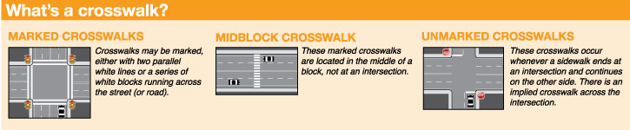

## Pedestrian Safety Tips

1. Look for cars in all directions – including those turning left or right – before crossing the street; never assume a driver will stop.
2. Be careful crossing multiple lanes of traffic. Make sure each lane of traffic is clear before you cross.
3. Enhance your visibility at night. Walk in well-lit areas, carry a flashlight or wear something reflective, such as stickers or armbands, to be more visible.
4. Avoid distraction. More and more we see people texting or talking on cell phones when crossing streets; this diminishes the ability of your two key senses – hearing and seeing – that are used to detect and avoid cars. So particularly when crossing streets, put down the phone for a few seconds.
5. Be predictable to drivers and follow the rules of the road; obey signs and signals.
6. Obey all pedestrian traffic signals.
7. Watch for cars backing up in parking lots; brake lights can mean that a car is about to back up.
8. Cross the street where you have the best view of traffic. At bus stops, cross behind the bus or at the nearest crosswalk.
9. Always walk on the sidewalk; if there is no sidewalk, walk facing traffic and as far from the roadway as you can.

Bicyclist Safety Tips

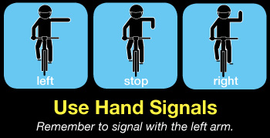

1. Wear a helmet. It could save your life.
2. Use a light and reflex mirrors or reflective clothing when bicycling at night, and be as visible as possible.
3. Ride in the direction of traffic. Drivers may not be looking for you if you are riding the wrong way.
4. Obey all signs and signals. This includes stopping at stop signs and red lights.
5. Use all of your senses – watch and listen for cars, particularly at intersections and drive ways.
6. Avoid distractions such as listening to headphones or answering phones when riding.

Motorist Safety Tips

1. Safety is a shared responsibility. Motorists need to be watchful for pedestrians and bicyclists, drive at slower speeds, avoid distraction, and know the laws regarding when pedestrians or bicyclists have the right-of-way.
2. Be prepared to yield to pedestrians in crosswalks.
3. Give a bicyclist at least four feet of space when passing, or you may completely enter the left lane if conditions are safe to do so.
4. Never pass a vehicle that is stopped for pedestrians.
5. Before making a turn, be sure the path is clear of any pedestrians or bicyclists.
6. Slow down in areas where you are likely to find pedestrians, such as near bus stops, schools, and playgrounds.
7. Look carefully behind your vehicle for approaching pedestrians before backing-up.
8. Keep an eye out for pedestrians at night that may be walking near or across the road.
9. Avoid distractions such as food, passengers and using mobile devices. Talking and texting while driving is both dangerous and [illegal in many places](http://handsfreeinfo.com/north-carolina-cell-phone-laws-legislation).